JOB DESCRIPTION

Role: Manager – Digital Health, LEHS|WISH

Number of Position(s): 1

Reporting: The Director - Digital Health
Location: Delhi

External Stakeholders: Government, Non-Govt Stakeholders, Vendors etc.

Internal Stakeholders: Cross functional teams across the organisation

Education: B.Tech/M.Tech/MCA/CSIT

Experience: The incumbent should have: 2-5 years of experience as a data manager/engineer/ data science specialist preferably in the field of health data

Language Proficiency: Hindi and English

Job Role:
Digital Health manager would support a team of developer in ensuring best practices in digital health product development including front-end, back-end and system architecture. The manager will closely work with project implementation team to understand the requirement and process flow of digital health management at the implementation and execution level, and replicate the need in form of robust applications compatible with mobiles and web-based platforms.

The main Job responsibilities will include (but not limited to):
The key responsibilities to be performed by the Data Manager includes the following:
- Lead multi-disciplinary team to develop and implement digital health products: Responsible for overseeing all aspects of the product, including development, implementation and sustainability.
- Liaison between digital health team and other stakeholders: Responsible for managing communications, expectation-setting and team work plan with internal stakeholders as well as product representation and partnerships discussions with external stakeholders
- Owner of new and existing digital health products: Responsible for overseeing and ensuring trajectory of product lifecycle is realized, from concept to design, prototype development, piloting, operational planning, implementation, sustainability planning and overall management of product.
- Integrate digital health policy compliances: Responsible building and integrating systems and software according to Digital health policy compliances. Should be aware about the Indian healthcare guidelines such as NDHM, Hippa compliances etc.
Any other reasonable duty as may be assigned, that is consistent with the nature of the job and the level of responsibility

Necessary Skills:
- Design & development of client-side and server-side application architectures
- Good understanding of OO principles, Algorithms, and Data Structures.
- Excellent problem-solving, debugging, and troubleshooting skills [Client side, Server side, Database.
- Expert-level skills in one or more of core JavaScript
- Data fluency: understands the basics of manipulating data and building analytical models, data management (Azure cloud, SQL, S3, Hadoop, R, Python) technologies and technology choice
- Experience working using CLI in Unix/Linux server environments.
- Experience managing and/or developing data science-based products
- Knowledge (2+ years) of Python language and JavaScript framework React and backend framework ( Django with libraries like django-rest-framework )

Desirable skills
- Experience leading a multi-disciplinary, lean team of data engineers and data analysts
- Interest or background in public health & govt. data systems
- Provide necessary Digital support to all the internal teams, programs and stakeholders
- Designing and developing APIs and REST endpoint.

Personal Attributes:
- Demonstrates integrity, ethics, compassion and respect;
- Passion for results- Highly motivated and resourceful; demonstrates high accountability, ownership and a go getter attitude; takes initiative and drives results;
- Demonstrates speed, agility and innovation in thought and in action;
- Decision-Making: S/he has the ability to evaluate risks and opportunities; uses analytical and problem-solving skills to arrive at sound business decisions;
- Result Focused: S/he effectively manages time and deliverables; has a strong sense of ownership; is able to multi-task and work under pressure; demonstrates attention to detail and sets high benchmarks;
- Willingness and ability to travel extensively as and when needed.

About us:
Lords Education and Health Society (LEHS) is a not-for-profit entity that was established in 2003. In 2014, the Wadhwani Initiative for Sustainable Healthcare (WISH), the flagship program of LEHS, was established. LEHS|WISH works towards improving the quality of and access to primary healthcare services for the under-served communities in India. WISH is implementing healthcare models through partnership with state governments, international agencies and the private sector by appropriately introducing promising healthcare innovations in the public health system in order to build an equitable, innovation-led and evidence-based quality healthcare system within easy reach of the underserved populations. LEHS|WISH is committed to building an equitable, quality-assured, innovation-led ecosystem that makes healthcare accessible to the most underserved.

Our Values  At LEHS|WISH we strive to live our values | Our Purpose- Vision, Mission and Goal  At LEHS|WISH our purpose governs all our action

Our Approach

Our work is positioned at the intersection of primary health care and innovations.
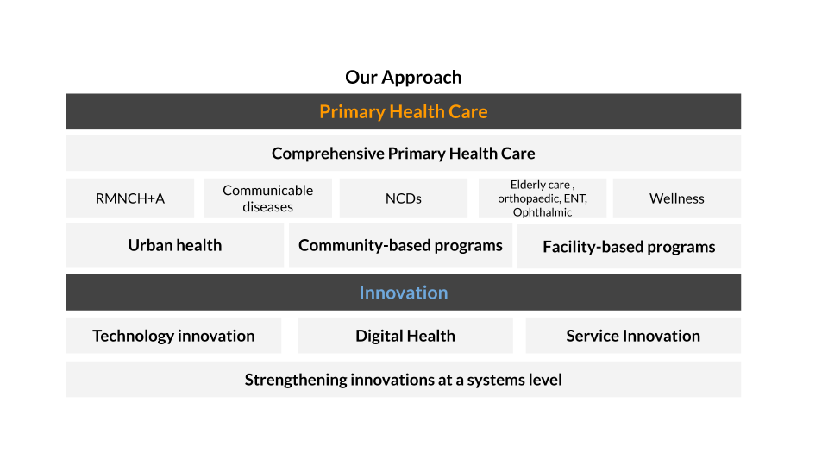
LEHS|WISH is an equal opportunity employer. All candidates applying for the position should submit their resume and cover letter specifying the position name in the subject line along with notice period and current/ expected compensation details to career@wishfoundationindia.org

