JOB DESCRIPTION

Position Title: Manager - Finance and Controllership
Number of Position(s): 1
Reporting: Head of Finance & Admin (HOFA)

Location: Delhi

Span of Control: Organization wide role

External Stakeholders: Government, Donors, Vendors etc.

Internal Stakeholders: CEO, Senior Director(s), Program Directors, State Directors, Functional Heads and entire WISH program and dissemination team

Education: Chartered Accountants (Only Qualified)
Experience/ Skills: The incumbent should have:

- Chartered Accountant (CA)
- Minimum 10 years’ experience in International NGO, Corporate in Controllership function
- Must possess excellent communication (fluent spoken and writing in English), inter personal skills, presentation and number skills (MS Excel advanced, Word, PPT). Working experience in Tally / other Accounting Software.
- Well versed with TAX, GAAP, GST, FCRA act and rules. Working experience in handling nuances applicable to foreign grants / FEMA regulations.
- Expertise in preparation and finalization of Monthly and Annual accounts, Preparation of Audit schedules and Co-Ordinate Audits from initiation to closure.
- Experience in process automation and SOX documentation.
Language Proficiency: Hindi and English

Job Role:
The key deliverables will include (but not limited to) the following:

- Ensure that all day-to-day financial transactions are correctly and timely validated and entered in the books of accounts.
- Lead the Accounts payable section and be responsible for meeting TAT for Payments to vendors and employees.
- Maintain the payables and advances within allowable threshold. Seek and maintain Quarterly NDC from all vendors and Consultants. Circulate ageing of payables and receivables monthly.
- Prepare Quarterly and Annual financials as per FCRA and Income Tax act, prepare schedules for statutory audits and co-ordinate with Auditors for LR or/and Annual Audit.
- Liaison with Bank for day-to-day banking activities, complete all required Banking documentations time to time, monitor and ensure that the team prepares BRS for all banks by 1st of every month.
- Maintain FD certificates, propose new Investments in FDs, Account accrued interest monthly, Review form 26AS, Facilitate Audit and Claim refund through ITR.
- Ensure that the Checklists, Authorisation Matrix / SOD, Guidelines, Policy has been adhered in the transactions being considered at the Payment desk/Accounts Payable sections and are being processed in compliance to above requirements.
- Maintain hygiene of Employee and Vendor Master in system and be responsible for control gaps if any developed during the day-to-day operation.
- Ensure payroll costs are timely and properly booked, paid and all Payroll statutory dues are paid on time and subsequent returns are filled before due date.
- Issue form 16 to employees and 16A to vendors on or before due dates.
- Account for Fixed and Program Assets, Run depreciation, amortise and other treatment as required with adequate approvals.
- Co-Ordinate with Admn and State leadership for Monthly stock take on Fixed Assets, Rent Payments, Payment of Utilities, Payment for Procurement, Advance Settlements or any other pending deliverables.
- Lead the team and ensure that Ticketing and Travel Vendor dues are timely paid and are correctly accounted-for as Provision in case Invoices are not booked by end of each month / close of Grant.
- Provide monthly reports to BFMs (Grant Finance POCs) on advances to be settled against their respective Grants.
- Maintain compliance tracker, plan and ensure all compliances are met well before the due date.
- Do ledger scrutiny, ensure closure of pending entries / adjustments/ settlements and circulate monthly reports / update dashboards regularly.
- Any other task to be assigned by the Supervisor.
Any other work that may be assigned as per the need and requirement of the organisation.

Personal Attributes:
- Should be a thorough professional, (Competent, Honest, Reliable, flexible, Respects others etc)
- Should be a team player and quick learner
- Experience in preparing financials, practicing Internal control measures (SOD / Auth Matrix, Policies, Guidelines etc.) and must be update with recent changes in Compliance eco-system.
- Should have prior experience in working in System automation modules (Contribution as subject matter expert in development / user)
- Experience in working as Grant finance POC shall be an added advantage.

About us:
Lords Education and Health Society (LEHS) is a not-for-profit entity that was established in 2003. In 2014, the Wadhwani Initiative for Sustainable Healthcare (WISH), the flagship program of LEHS, was established. LEHS|WISH works towards improving the quality of and access to primary healthcare services for the under-served communities in India. WISH is implementing healthcare models through partnership with state governments, international agencies and the private sector by appropriately introducing promising healthcare innovations in the public health system in order to build an equitable, innovation-led and evidence-based quality healthcare system within easy reach of the underserved populations. LEHS|WISH is committed to building an equitable, quality-assured, innovation-led ecosystem that makes healthcare accessible to the most underserved.

Our Values  At LEHS|WISH we strive to live our values | Our Purpose- Vision, Mission and Goal  At LEHS|WISH our purpose governs all our action

Our Approach
Our work is positioned at the intersection of primary health care and innovations.
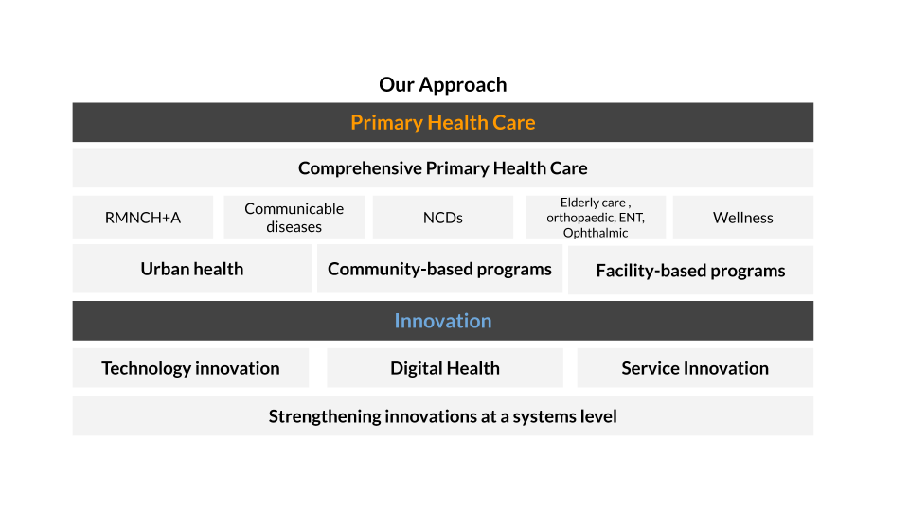

LEHS|WISH is an equal opportunity employer. All candidates applying for the position should submit their resume and cover letter specifying the position name in the subject line along with notice period and current/ expected compensation details to career@wishfoundationindia.org

