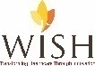

JOB DESCRIPTION
Position Title: Manager/Senior Manager – Strategic Communications
Reporting: Head, Strategic Communication
Location: Delhi
Span of Control: This role will cater to around 100 - 150 employees in the organization
External Stakeholders: Vendors, Consultants
Internal Stakeholders: CEO, Sr Program Director(s), Directors, Function Heads, all staff/ SPOCs at State & HO level
Education:
- Essential: M.A. (Journalism/Media/English Literature/Social Sciences)
- Desirable: Social/Development/Public Health sector experience would be an added plus
Experience: The incumbent should have:
- Essential:
At least 10-16 years of experience in managing strategic communication at organizational level
Expertise in communicating with donors, media, and other external stakeholders
Developing communication resources for the organization as per the requirements
- Desirable:
Social/Development/Public Health Sector Experience
Language Proficiency: Hindi and English

Communication Manager/Specialist (Mid-Level): LEHS|WISH is seeking a seasoned Communication Manager/Specialist, with strong writing skills and a flair for social media content generation. S/he should have a good understanding of social media platforms to support the organisation’s external communication and outreach goals. S/he would be expected to write high-quality content for internal and external audiences and assist with daily administration of digital communication channels. This role requires highly motivated communication professionals who are committed to bring change in human lives through their work.
The Specialist/ Manager will lead department initiatives under the mentorship and oversight of Head Strategic Communications and understand, promote Strategic Communications’ goals, aligned with institutional goals.
The incumbent will exemplify the mission, vision and cultural values of LEHS|WISH through his/her actions, and effectively use print, and digital communication media/platforms to showcase LEHS|WISH achievements and impact, leading to enhanced organizational image and functional competence.

Job Role: The incumbent must have demonstrated expertise in the following areas including (but not limited to):
- Lead communications, outreach initiatives and planning under the mentorship of Head Strategic Communications and other relevant internal stakeholders
- Assist in developing and implementing a communications’ strategy including a detailed Social Media Strategy
- Develop strong understanding of departmental and institutional goals, strategies and ensure they are integrated into communications initiatives
- Identify, research and write useful, engaging content on LEHS|WISH for target audiences with an aim to project its core area of work, impact of our work on Last Mile population by using various communication platforms such as social media, and industry or mainstream news channels, newspapers and other audio and video platforms (national and global both)
- Interview beneficiaries, stakeholders such as govt and community at large, as well as executives and senior technical experts on the subject related to LEHS|WISH work
- Collaborate with program and technical team members for the purpose of creating content for external audiences
- Support daily administration of digital communication channels, primarily external
- Identify and support in ensuring practice participation in global development forums to showcase technical expertise and contributions towards building the primary healthcare ecosystem
- Provide timely communications expertise by responding to inquiries and depending on need and availability, to the field by taking short-term technical assignments

Any other reasonable duty as may be assigned by Head, Strategic Communication, that is consistent with the nature of the job and the level of responsibility.

What kind of a person would be a right fit?
Someone who has:
- Strong writing, and communication skills in English and Hindi languages
- High orientation towards accuracy, eye for detail and excellence in work
- Methodical and diligent in terms of maintaining checklists for task completion and tracking for closure
- Multitasker, who can handle a spectrum of activates with ease and calm
- Passionate about the work, and the contributions s/he will make

Personal Attributes:
- Demonstrates integrity, ethics, compassion, positivity and respect;
- Passion for results – Highly motivated and resourceful; demonstrates high accountability, ownership and a go getter attitude; takes initiative and drives results;
- Demonstrates speed, agility and innovation in thought and in action;
- Decision-Making: S/he has the ability to evaluate risks and opportunities; uses analytical and problem-solving skills to arrive at sound business decisions;
- Result Focused: S/he effectively manages time and deliverables for self and team; has a strong sense of ownership; is able to multi-task and work under pressure; demonstrates attention to detail and sets high benchmarks;
- People Management: Demonstrated capacity to build and lead small team; possesses strong interpersonal abilities and provides necessary direction to team with focus on skill building, overall staff development, enhanced performance and engagement levels; Emotionally intelligent, perceptive and demonstrates inclusiveness and diversity;
- Willingness and ability to travel as needed.

About us:

Lords Education and Health Society (LEHS) is a not-for-profit entity established in 2003, and registered under the Societies Registration Act, 1860. The Wadhwani Initiative for Sustainable Healthcare (WISH) is the flagship program of LEHS.

LEHS|WISH works towards improving the quality of and access to primary healthcare services for the under-served communities in India. WISH is implementing healthcare models through partnership with state governments, international agencies and the private sector by appropriately introducing promising healthcare innovations in the public health system in order to build an equitable, innovation-led and evidence-based quality healthcare system within easy reach of the underserved populations. LEHS|WISH is committed to building an equitable, quality-assured, innovation-led ecosystem that makes healthcare accessible to the most underserved.

Our Values  At LEHS|WISH we strive to live our values | Our Purpose- Vision, Mission and Goal  At LEHS|WISH our purpose governs all our action

Our Approach
Our work is positioned at the intersection of primary health care and innovations.
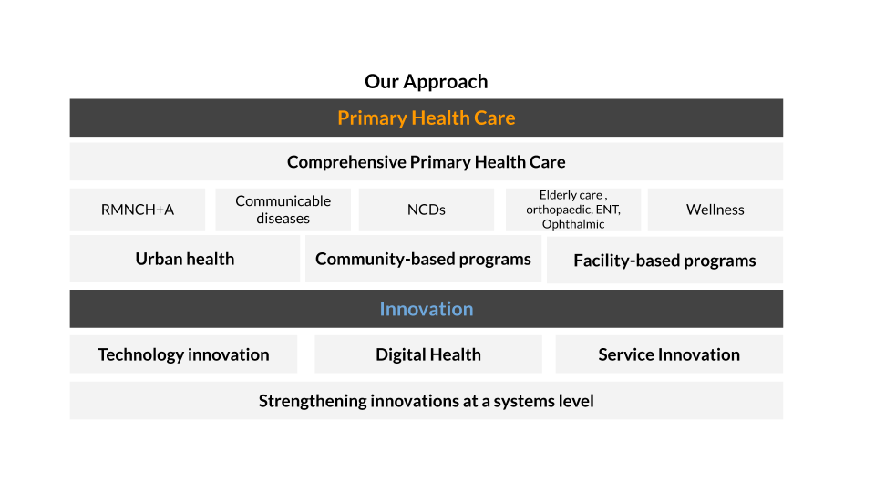

LEHS|WISH is an equal opportunity employer. All candidates applying for the position should submit their resume and cover letter specifying the position name in the subject line along with notice period and current/ expected compensation details to career@wishfoundationindia.org

