JOB DESCRIPTION

Role: Officer - Administration, LEHS|WISH

Number of Position(s): 1

Reporting: Manager - Administration
Location: Delhi
External Stakeholders: Vendors/Suppliers, Outsourced Manpower Agency, Transporters

Internal Stakeholders: Cross functional teams across the organization, Outsourced pantry and housekeeping staff, Driver

Education: Graduate with good academic record preferably computer science, Good communication and PR skills, Team player
Experience: 5-6 years of experience of working in development sector with Admin and Procurement domain. Excellent verbal, written and communication skills, fluency in Hindi & English. Self-motivated & ability to work in a team
Job Role:

The person recruited for this position will be the overall responsible for Admin & Procurement role at Wish Foundation Head Office, New Delhi. Main role is to coordinate the functions of Admin Operations and Procurement through ERP platform. The person will directly report to the Specialist/Manager-Administration. Quality procurement, Procurement arrangements, coordinating supporting admin operations, organize procurement of services/goods/consumables / stationery supplies as required for the state office and monitor its use as mandated by Standard Operating Procedure (SOP). Overall responsible for Office administration and smooth transaction.
Responsibilities:
Support Procurement and Supply Chain:
Organize procurement of medical consumables, equipment’s as required for program implementation team and monitor its use as mandated by Standard Operating Procedure (SOP)
Support in preparing Procurement Plan in coordination with Program Team
Ensure that vendor list is updated and Procurement Policy is followed
Negotiate to get best value for good and services.
Ensure effective and accountable Procurements support to the field team

Support in ensuring smooth administrative services
Adherence to Admin SOP
Maintain stock register of consumables and office equipment
Coordinate maintenance of all office equipment and utilities
Maintain communication with state offices through e-mail, fax, courier and post
Support in ensuring timely payments to Vendors
Travel and Procurement Arrangement (If required)
Organize travel and stay for state staff visiting outside and for visitors to the state
Provide support in organizing workshops / seminars initiated in the state
Provide support during any emergency
Provide Procurement support for events – venue selection, printing, distribution etc.
Ensure management of vehicles and appropriate allocation and their safe use.
Management of Records and Assets
Maintain all PO records, MoU, Agreements in digital as well as hard copy files
Maintaining the filing system in their respective locations
Provide assistance to other units in liaising with vendors, transporters and landlords
Coordinate assisting administrative support during emergency responses, as required by the team
Others:
Coordinate with Programme Team to make their procurements (Service and products) as per the programs/project requirements
Orientation of procurement procedures to the program teams
Review of PR requests and processing the procurements
Ability to operate and promote cost-effective procurements to maximize resources for beneficiaries
Undertake additional responsibilities as and when assigned in the best interests of the organisation
Contribute to a positive working environment.
Promote the work of Wish Foundation– communicating, both internally and externally, in an accurate, sensitive and motivating fashion
Adhering to financial norms and procedures of Wish Foundation
Other ad hoc duties as required in line with your skills, experience and role
Necessary Skills:
Willingness to work irregular hours when the job dictates (such as for events, in emergency response times etc.)
Good skills in basic computer applications

Personal Attributes:
- Excellent communication, interpersonal, and negotiation skills
- Ability to work long hours and under pressure, when necessary
- Good relationship building, able to get things done at all levels
- Strong team skills. Willing to cooperate with others and work in a participatory manner
- to achieve established goals
- High level of professionalism in conduct
- High degree of professional and personal integrity
- Positive attitude: High motivation, proactive & flexible-yet-uncompromising
- Quick learner
- Respect for deadlines
- Attention to details
- Ability to work long hours under pressure
- Team player

About us:
Lords Education and Health Society (LEHS) is a not-for-profit entity that was established in 2003. In 2014, the Wadhwani Initiative for Sustainable Healthcare (WISH), the flagship program of LEHS, was established. LEHS|WISH works towards improving the quality of and access to primary healthcare services for the under-served communities in India. WISH is implementing healthcare models through partnership with state governments, international agencies and the private sector by appropriately introducing promising healthcare innovations in the public health system in order to build an equitable, innovation-led and evidence-based quality healthcare system within easy reach of the underserved populations. LEHS|WISH is committed to building an equitable, quality-assured, innovation-led ecosystem that makes healthcare accessible to the most underserved.

Our Values  At LEHS|WISH we strive to live our values | Our Purpose- Vision, Mission and Goal  At LEHS|WISH our purpose governs all our action

Our Approach

Our work is positioned at the intersection of primary health care and innovations.
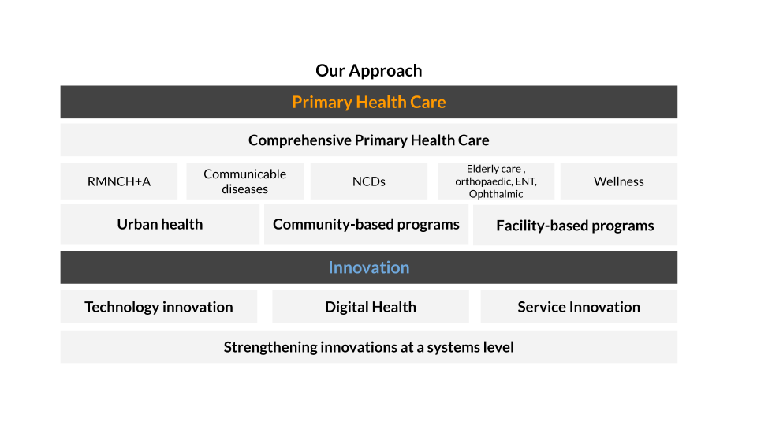
LEHS|WISH is an equal opportunity employer. All candidates applying for the position should submit their resume and cover letter specifying the position name in the subject line along with notice period and current/ expected compensation details to career@wishfoundationindia.org
Date of job posting: 3 January, 2023
Apply before January 15, 2023 for best consideration

