JOB DESCRIPTION

Position Title: Deputy/Associate Director Health System Strengthening (Comprehensive Primary Health Care + Urban health)
Number of Position(s): 1

Reporting: Sr. Program Director

Location: New Delhi

Number of Direct Reports: 2-5

Span of Control: Organization wide role

External Stakeholders: Government, Donors, Vendors etc.

Internal Stakeholders: CEO, Senior Director(s), Program Directors, State Directors, Functional Heads and entire WISH program and dissemination team

Education: Post-graduate level degree (MD Community Health/MPH/ MBA in Healthcare/Masters in Health Policy) preferably from a recognized institution/university. Certificate/ Program course in Health Policy, Health systems, Planning and other similar course would be desirable.

Experience/ Skills: The incumbent should have:

- Minimum 12-15 years of post-qualification experience of developing strategies/policies/plan of actions in the field of Health Systems Strengthening, especially primary health care in rural and urban areas. Candidates with experience of working with the national government on programmatic and policy level will be given preference.
- Experience of working collaboratively with different partners at the national and/or state level, and influencing government policies and practices on system issues through partnerships and evidence-informed advocacy
- Willingness to travel to States & districts to provide technical assistance & ability to work on different assignments simultaneously to meet the timelines.
- Computer proficiency with high level of familiarity with commonly used packages like MS Word, Excel, Power Point.

Language Proficiency: Hindi and English

Deputy/Associate Director Health System Strengthening (Comprehensive Primary Health Care + Urban health)
The incumbent will be the key to the techno-advisory vertical of Programmes and will work towards amplifying the organizational impact by providing technical, advisory and programmatic oversight and strategic direction for health system strengthening (HSS) in the areas of CPHC and Urban health blended with digital technology and innovations at all stages of programming. S/He will ensure that the programmatic priorities, strategies and approaches rest on best practices, newer approaches and the current evidence base relevant to priority areas. The incumbent will report to the Senior Director Programs.
The position will contribute towards establishing a culture of respect, trust, collaboration, learning, innovation, urgency and passion for quality results within the team members and their workings. The individual will exemplify the mission, vision and cultural values of LEHS|WISH through his or her actions.

Job Role:

The key deliverables will include (but not limited to) the following:

- Lead development of technically-sound, health systems strengthening approaches, proposals, programs, tools, and methodologies to guide interventions, using a systems-thinking lens across program activities, tailored to the local context.
- Contribute to the development, integration and operationalization of state specific policies and plans for timely implementation and scale up of the Ayushman Bharat Scheme, with attention to comprehensive Primary Health Care (PHC) blended with technology and Innovation. This would include supporting the States/UTs in developing strategies and plans including resource allocation, program indicators and targets; organising orientation and trainings for the States/UTs, and coordination with them for convergent actions in providing universal health coverage.
- Lead provision of technical assistance to programme operation teams for implementation of activities including establishing performance targets adhering to monitoring plans, and responsible for ensuring quality of programmes as per the defined indicators.
- Work together with the Programme Operations and Learning & Impact team in documentation and synthesis of learning, and help in identifying opportunities for sharing lessons/results at the state, national, and international level.
- Design and develop context-specific service delivery models on Primary Health Care and workflow dynamics in a geographically defined area. Promote adoption and scale up of promising practices and models of CPHC in both rural and urban areas, exploring the use of technology for tackling systemic challenges.
- Lead/support relationship management with National/State/City Government, donors, partners and other stakeholders, and represent the organization at different technical forums and platforms. Advocate for policies/strategies based on the learnings emerging from the organizational work/priorities and global studies, and commitments from Government, donors and other partners through collaborative efforts and coalition.
- Support in establishing and strengthening of coalitions/networks, and strategic partnerships with the Government, statutory bodies, academia, civil society organizations etc. towards realization of the goals and objectives of the organization in relation to Primary Health Care.
- Create in-house platforms and mechanisms for cross-learning and share updated information, best practices and resource materials on HSS, CPHC, Urban health.
- Collaborate with cross-sectoral and cross functional teams at the National and State level (both intra-programme and inter-programme) for necessary synergies and alignment
- Undertake periodic field visits to States/UTs and districts to review HWCs and CPHC services, identify challenges and support States/UTs for overcoming these challenges.
- Other duties, which may be assigned from time to time.

Any other work that may be assigned as per the need and requirement of the organisation.

Personal Attributes:
- Demonstrates integrity, ethics, compassion and respect;
- Passion for results- Highly motivated and resourceful; demonstrates high accountability, ownership and a go getter attitude; takes initiative and drives results;
- Demonstrates speed, agility and innovation in thought and in action;
- Decision-Making: S/he has the ability to evaluate risks and opportunities; uses analytical and problem-solving skills to arrive at sound business decisions;
- Result Focused: S/he effectively manages time and deliverables for self and team; has a strong sense of ownership; is able to multi-task and work under pressure; demonstrates attention to detail and sets high benchmarks;
- Thought Leadership: Thinks creatively and innovatively; turns ideas into reality and is able to replicate and scale ideas into sustainable change across ecosystems; has strong influencing skills which enable her/him to work effectively across internal and external stakeholders; Is looked upon as an informed opinion leader and a trusted source/ go-to person in the field;
- Brand Ambassador: Has a strong professional presence and can be seen as a credible and key representative of WISH to forge strong strategic partnerships;
- People Management: Demonstrated leadership capacity to build and lead technology teams; possesses strong interpersonal abilities and provides necessary direction to team with focus on skill building, overall staff development, enhanced performance and engagement levels; Emotionally intelligent, perceptive and demonstrates inclusiveness and diversity;
- Willingness and ability to travel extensively

About us:
Lords Education and Health Society (LEHS) is a not-for-profit entity that was established in 2003. In 2014, the Wadhwani Initiative for Sustainable Healthcare (WISH), the flagship program of LEHS, was established. LEHS|WISH works towards improving the quality of and access to primary healthcare services for the under-served communities in India. WISH is implementing healthcare models through partnership with state governments, international agencies and the private sector by appropriately introducing promising healthcare innovations in the public health system in order to build an equitable, innovation-led and evidence-based quality healthcare system within easy reach of the underserved populations. LEHS|WISH is committed to building an equitable, quality-assured, innovation-led ecosystem that makes healthcare accessible to the most underserved.

Our Values  At LEHS|WISH we strive to live our values | Our Purpose- Vision, Mission and Goal  At LEHS|WISH our purpose governs all our action

Our Approach
Our work is positioned at the intersection of primary health care and innovations.
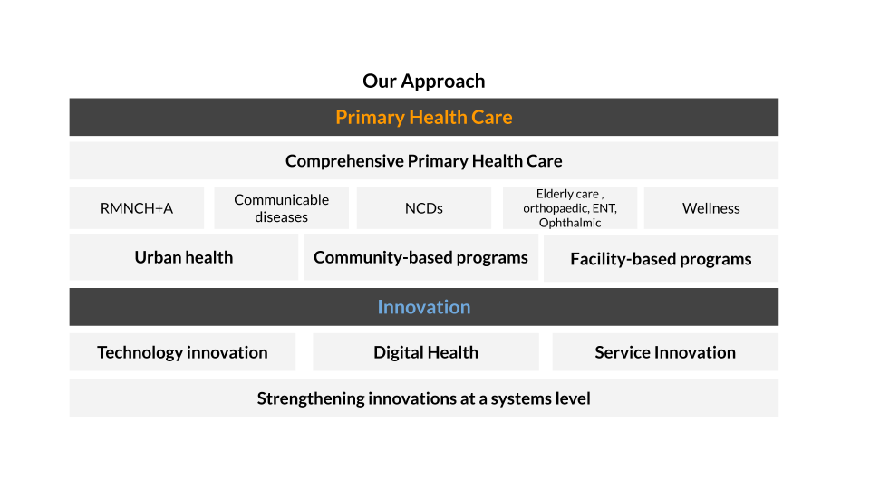
LEHS|WISH is an equal opportunity employer.

