JOB DESCRIPTION

Position Title – IT Specialist - Project Management Unit (PMU) for Brihanmumbai Municipal Corporation (BMC)
Number of Position(s): 1

Reporting: Team lead, PMU

Location: Mumbai

Education: B.Tech/M.Tech/MCA/CSIT

Span of Control: Within PMU.
Internal Stakeholders: CEO, Program Director, Functional Heads and entire WISH program and dissemination team.
External Stakeholders: BMC official and other development partners.

Experience/ Skills: The incumbent should have:

- Candidates should have 8 years of experience. Minimum 3 years’ experience with the government/supporting government programs.
- In-depth knowledge of VMWare, Microsoft Windows/Server, Linux OS, Google Apps administration, AWS/Azure Cloud Administration, Network Administration and Service Desk Administration
- Excellent written and verbal communication and problem-solving skills.
- Able to clearly communicate technical concepts to both technical and non-technical audiences.
- Knowledge of SOC 2 and CMMC compliance requirements.
- CompTIA Advanced Security Practitioner (CASP) certification.
- Additional Network/Security/System Architecture Certificate would be a plus
- Willingness to travel to provide technical assistance & ability to work on different assignments simultaneously to meet the timelines.

Language Proficiency: English and Marathi

Primary Health Care is the interface between the secondary and tertiary health care system and the urban poor and has a pivotal role in delivering necessary primary healthcare services to the urban population particularly in the slums and to the vulnerable sections. In order to address the health concerns of the urban population more effectively and to provide basic essential primary care in close proximity for urban slums, Brihanmumbai Municipal Corporation has introduced the concept of “HBT Clinic” - Essential health care services at time and place convenient and feasible to the citizens. Additionally, HBT Polyclinic and Diagnostic Centers are being set up to upgrade the existing dispensaries where specialist consultation services along with certain diagnostic services (Blood Investigations, X- Ray, USG, ECG etc) will be available.
The overall objective of the initiative is to incorporate specialized set of interventions at primary health care by roping in basic healthcare and access to specialized diagnostic services to improve promotive, preventive, curative health care and to reduce the burden on secondary and tertiary health care system. Specific objectives include
- To strengthen the primary healthcare delivery system for making quality & essential healthcare services accessible, available and affordable to maximum citizens, especially urban slum and vulnerable populations.
- To reduce out of pocket expenditure for accessing basic healthcare services and reduce the load on secondary and tertiary healthcare system.
- To demonstrate technology and innovation led primary healthcare model to improve the access to comprehensive primary healthcare services with focus on general ailments, NCDs, and infectious diseases.
- To improve primary healthcare system, planning, and policy-making through on-field monitoring, data management and evidence-based solutions.
The BMC has invited partners to establish a Program Management Unit (PMU) to provide “technical assistance and knowledge management support” in achieving the above objectives. LEHS/WISH has applied for the same, and in anticipation is seeking application from qualified and experienced candidates for the position of Technical Specialist NCD, PMU. The incumbent will work under the team lead towards amplifying the organizational impact by providing technical, advisory and strategic direction to the proposed PMU of the BMC.
The position will contribute towards establishing a culture of respect, trust, collaboration, learning, innovation, urgency and passion for quality results within the team members and their workings. The individual will exemplify the mission, vision and cultural values of LEHS|WISH through his or her actions.
Job Role:
The key deliverables will include (but not limited to) the following:
- Management and provisioning of required IT infrastructure as IaaS for hosting Health Application.
- Understanding of SDLC Processes for
a. Staging
b. Production
c. Disaster Recovery
- Active Directory Services - To facilitate Active Directory Services & Domains, Manage Enterprise Group Policies and Security Policies, Perform backup and recovery of AD servers and AD objects, AD Groups and Group Policies, User Management.
- Email Management - Managing mail servers and mail messaging solution (MS365, Gsuite), Implemention Mail Policies, User Security, Access Control, Encryption, Spam Control, Content Filtering, Mailbox Setup, Backup, Mail Queues, Routing Incoming Outgoing mail, Virus Engine, SMTP Routing Settings, Manage Trust IP’s, Blocking and Anti Spam Management.
- Asset Management – Recommend the provisioning and deprovisioning of Windows, Mac, and Linux devices, Remote desktop control, Patch management, System migration, Optimizing existing process and recommending changes for optimal functioning. Tagging assets, Managing Warranty and Expiry Alert.
- Cloud Management – To facilitate the provisioning required compute infrastructure (server/virtual machines), storage on AWS/Azure/Private Cloud, Security Protocols, Resource Optimization, Server Upkeep, Monitoring and Review, Reporting on Weekly/Monthly Basis.
- Network Administration – Firewall,Gateway, LAN WAN Setup, VLAN, SDLAN, VPN, SSL, Spam Filter, Anti Malware, Patch Management, Deskop/Laptop Support, MS365 Office/ Outlook Management.
- Managing Internet, ISP related queries and Vendor Management.
- Knowledge & Management of Standard Data Recovery, Password Recovery, Data Back and Disaster Recovery Protocols.
- Configuring the print server and resolving all printing problems of users.
- Besides this all-other miscellaneous IT activity will be carried out by engineer as per requirement.
- Developing & implementing policy related to information security and privacy concerns.
- Develop and maintain IT-related documentation on supported applications, processes, and training materials for employees.
- Identifying potential problems with existing systems and recommending improvements to existing processes.
- Any other work that may be assigned as per the need and requirement of the organization.

Personal Attributes:
- Demonstrates integrity, ethics, compassion and respect;
- Passion for results- Highly motivated and resourceful; demonstrates high accountability, ownership and a go getter attitude; takes initiative and drives results;
- Demonstrates speed, agility and innovation in thought and in action;
- Decision-Making: S/he has the ability to evaluate risks and opportunities; uses analytical and problem-solving skills to arrive at sound business decisions;
- Result Focused: S/he effectively manages time and deliverables for self and team; has a strong sense of ownership; is able to multi-task and work under pressure; demonstrates attention to detail and sets high benchmarks;
- Brand Ambassador: Has a strong professional presence and can be seen as a credible and key representative of WISH;
- Willingness and ability to travel;

About us:
Lords Education and Health Society (LEHS) is a not-for-profit entity that was established in 2003. In 2014, the Wadhwani Initiative for Sustainable Healthcare (WISH), the flagship program of LEHS, was established. LEHS|WISH works towards improving the quality of and access to primary healthcare services for the under-served communities in India. WISH is implementing healthcare models through partnership with state governments, international agencies and the private sector by appropriately introducing promising healthcare innovations in the public health system in order to build an equitable, innovation-led and evidence-based quality healthcare system within easy reach of the underserved populations. LEHS|WISH is committed to building an equitable, quality-assured, innovation-led ecosystem that makes healthcare accessible to the most underserved.

Our Values  At LEHS|WISH we strive to live our values | Our Purpose- Vision, Mission and Goal  At LEHS|WISH our purpose governs all our action

Our Approach
Our work is positioned at the intersection of primary health care and innovations.
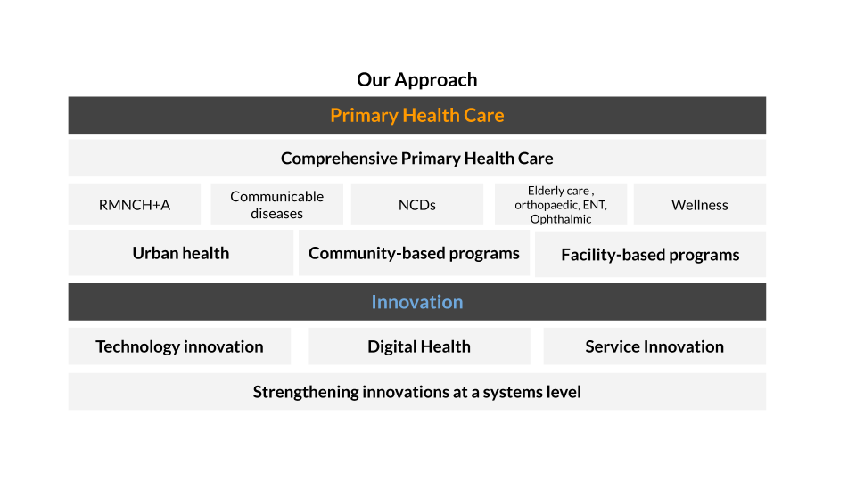
LEHS|WISH is an equal opportunity employer. All candidates applying for the position should submit their resume and cover letter specifying the position name in the subject line along with notice period and current/ expected compensation details to career@wishfoundationindia.org

Date of job posting: October 20, 2022
Please apply by November 3, 2022 for best consideration

