JOB DESCRIPTION

Position Title: Manager / Specialist – Business Development, LEHS|WISH

Number of Position(s): 1

Reporting: Business Development Head

Location: New Delhi

Span of Control: Individual contributor role

External Stakeholders: Government, Philanthropic Agencies, Multilateral and Bilateral Donors, CSRs, Corporate and their foundations, Vendors etc.

Internal Stakeholders: Cross functional teams across the organisation

Education:
- Essential: Bachelor’s Degree in Business Administration, Marketing, Finance, Fundraising or similar area
- Desirable: Management Degree would definitely be an added plus

Experience: The incumbent should have:
Essential:
- At least 10 years progressive overall experience out of which at least 5 years plus should be in generating Funds in a similar functional context
- Strong experience in proposal writing for big bilateral and multilaterals
- Research and database management
- Demonstrated success in raising grants and securing new donor partners
- Excellent problem solving and quick decision making

Desirable/ Preferable:
- Prior experience in the development sector, International NGO experience will be an added advantage
- Prior experience in health domain

Functional Skills:
- Demonstrate sensitivity to relationships with major donors and influential community leaders, maintaining high degree of confidentiality
- Develop strong working dynamics with cross functional teams. Actively participate in planning and meeting goals as an integral team member
- Responding with agility and openness to opportunities and challenges that may arise throughout the process for quick solutioning
- Strong financial and number orientation
- Knowledge of health domain, organisation’s products and USP to position it effectively
Language Proficiency: Hindi and English

Job Role:
We are searching for a mid-level professional with excellent writing, researching and networking abilities. Key responsibilities of the incumbent would be to support and lead the following, in close collaboration with the Business Development Head and BD Team:
- Research and identify prospective CSRs, Foundations, Institutional donors, Multi-lateral and Bilateral donors, HNI and corporate funders
- Own and drive end to end activities required to write and submit grant proposals to individual, foundation, institutional and corporate prospects. This shall include but not be limited to: write and edit letters of intent, concept notes; propose ideas and develop proposals and budgets for submission, including assembling all required documentation for funding opportunities
- Grant/ External/ Internal Reporting:
*Write, edit, and oversee the completion and submission of all reports
*Ensure compliance with donor grant restrictions and reporting preferences
*Maintain repository of all internal and external reports
* Work in close collaboration with the Finance team to prepare contractual and financial reports as needed
*Editing reports for team members, as needed
*Work with colleagues to compile, write, and finalize fundraising content for the annual report
- Collaborate with the Strategic Communications team to share and produce ongoing consistent language and visual content
- Develop, update and maintain a central folder with repository of latest templates, boiler-plate materials, written content which can be leveraged by internal teams- including materials to support donor relationships and visibility, in form of Power Points, summaries etc.
Any other reasonable duty as may be assigned, that is consistent with the nature of the job and the level of responsibility as deemed fit by the reporting manager or any other designated person.
Personal Attributes:
- Demonstrates integrity, ethics, compassion and respect;
- Passion for results: Highly motivated and resourceful; effectively manages time and deliverables for self; has a strong sense of ownership; is able to multi-task and work under pressure; demonstrates attention to detail and sets high benchmarks;
- Speed and Agility: Demonstrates these in thought and action; Adherence to targets and deadlines; Does not compromise on quality of output in the process
- Teamwork: Collaborates with others in own team, across other project/ support teams in the organisation and external stakeholders; Willing to seek and provide help as needed; Acknowledges others' contributions; respectfully puts across his/her points of view across all levels Good Communication skills;
- Learning and Knowledge Sharing: Open to unlearning and learning new ideas; Demonstrates knowledge sharing with colleagues (doesn’t hold on to information); Applies knowledge in daily work;
- Communication: Effectively articulates and presents ideas/ concepts (verbal and written) to a variety of internal and external audiences with clarity and confidence; Demonstrates strong listening skills;
- Solutionist Mindset: Open to exploration of new ideas and creative thinking for finding answers/ solutions rather than complicating/ concentrating on hurdles, within limited resources and situational constraints;
- Willingness and ability to travel as and when required.
About us:
Lords Education and Health Society (LEHS) is a not-for-profit entity that was established in 2003. In 2014, the Wadhwani Initiative for Sustainable Healthcare (WISH), the flagship program of LEHS, was established. LEHS|WISH works towards improving the quality of and access to primary healthcare services for the under-served communities in India. WISH is implementing healthcare models through partnership with state governments, international agencies and the private sector by appropriately introducing promising healthcare innovations in the public health system in order to build an equitable, innovation-led and evidence-based quality healthcare system within easy reach of the underserved populations. LEHS|WISH is committed to building an equitable, quality-assured, innovation-led ecosystem that makes healthcare accessible to the most underserved.

Our Values  At LEHS|WISH we strive to live our values | Our Purpose- Vision, Mission and Goal  At LEHS|WISH our purpose governs all our action

Our Approach

Our work is positioned at the intersection of primary health care and innovations.
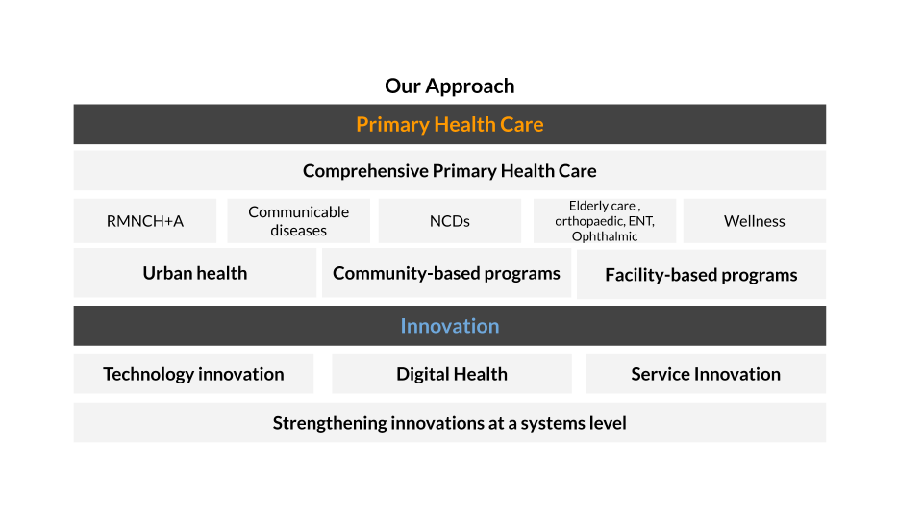
LEHS|WISH is an equal opportunity employer.

