JOB DESCRIPTION

Role: Program Specialist, LEHS|WISH

Number of Position(s): 3

Reporting: Director – Learning labs/ Centres of Excellence
Location: Delhi

External Stakeholders: Government, Non-Govt Stakeholders, Vendors etc.

Internal Stakeholders: Cross functional teams across the organisation

Education: Post Graduation in Business/ Public Health/ Economics or related fields

Experience: At least five years of experience in public health/ technology/ consulting/ data analytics from reputable organizations.

Job Role:

The role shall be carved out taking into consideration the profile, interests, and experience of the candidate; and other organizational requirements. Job responsibilities could include:
- Program Planning: Device comprehensive processes and metrics to ensure that benefits of the program accrue to the final beneficiaries.
- Process Excellence: Identify areas to enhance programmatic efficiency, to minimize administrative costs and optimize outcomes.
- Program Strengthening: Train program/ field staff on new initiatives and support the team as needed.
- Convergence: Work across projects and stakeholders to build relationships and drive convergence, to maximize beneficiary welfare.
- Research & Innovation: Research on program landscape, best practices, innovations and act as a conduit of knowledge from other organizations in the ecosystem.
- Evaluation & Dissemination: Support evaluation studies at output and outcome levels. Identify best modes of dissemination to help drive the ecosystem forward.

Necessary Skills:
- Capable of driving projects independently
- A keen interest in research and analytics

Personal Attributes:
- Demonstrates integrity, ethics, compassion and respect;
- Passion for results- Highly motivated and resourceful; demonstrates high accountability, ownership and a go getter attitude; takes initiative and drives results;
- Demonstrates speed, agility and innovation in thought and in action;

About us:
Lords Education and Health Society (LEHS) is a not-for-profit entity that was established in 2003. In 2014, the Wadhwani Initiative for Sustainable Healthcare (WISH), the flagship program of LEHS, was established. LEHS|WISH works towards improving the quality of and access to primary healthcare services for the under-served communities in India. WISH is implementing healthcare models through partnership with state governments, international agencies and the private sector by appropriately introducing promising healthcare innovations in the public health system in order to build an equitable, innovation-led and evidence-based quality healthcare system within easy reach of the underserved populations. LEHS|WISH is committed to building an equitable, quality-assured, innovation-led ecosystem that makes healthcare accessible to the most underserved.

Our Values  At LEHS|WISH we strive to live our values | Our Purpose- Vision, Mission and Goal  At LEHS|WISH our purpose governs all our action

Our Approach

Our work is positioned at the intersection of primary health care and innovations.
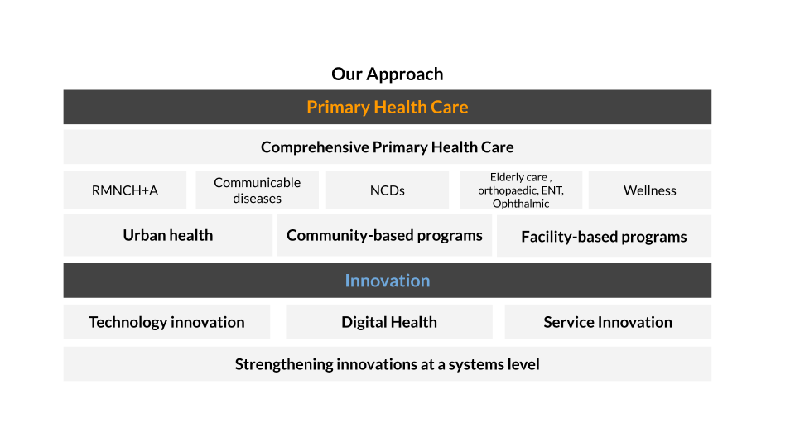
LEHS|WISH is an equal opportunity employer. All candidates applying for the position should submit their resume and cover letter specifying the position name in the subject line along with notice period and current/ expected compensation details to career@wishfoundationindia.org
Date of job posting: December 23, 2022

