JOB DESCRIPTION

Position Title: Project Manager (Urban Health)- Project Management Unit (PMU) for Brihanmumbai Municipal Corporation (BMC)

Number of Position(s): 1 Reporting: Team Lead PMU Location: Mumbai
Internal Stakeholders: CEO, Program Director, Functional Heads and entire WISH program and dissemination team.

Education: MBBS/MPH/MPA

Experience/ Skills: The incumbent should have:

- Minimum 5 years of experience of implementing and monitoring in the field of Health Systems Strengthening, especially primary health care in rural and urban areas.
- Minimum 1 year of experience of providing programmatic support to the national government/ state government/ city ULBs on program implementation and monitoring around urban health will be given preference.
- Excellent oral and written communication skills
- Willingness to travel to provide technical assistance & ability to work on different assignments simultaneously to meet the timelines.
- Computer proficiency with high level of familiarity with commonly used packages like MS Word, Excel, Power Point.

Language Proficiency: English and Marathi

Primary Health Care is the interface between the secondary and tertiary health care system and the urban poor and has a pivotal role in delivering necessary primary healthcare services to the urban population particularly the slum and vulnerable sections. In order to address the health concerns of the urban population more effectively and to provide basic essential primary care in close proximity for urban slums, Brihanmumbai Municipal Corporation has introduced the concept of “HBT Clinic” - Essential health care services at time and place convenient and feasible to the citizens. Additionally, HBT Polyclinic and Diagnostic Centers are being set up to upgrade the existing dispensaries where specialist consultation services along with certain diagnostic services (Blood Investigations, X- Ray, USG, ECG etc) will be available.

The overall objective of the initiative is to incorporate specialized set of interventions at primary health care by roping in basic healthcare and access to specialized diagnostic services to improve promotive, preventive, curative health care and to reduce the burden on secondary and tertiary health care system. Specific objectives include

- To strengthen the primary healthcare delivery system for making quality & essential healthcare services accessible, available and affordable to maximum citizens, especially urban slum and vulnerable populations.

- To reduce out of pocket expenditure for accessing basic healthcare services and reduce the load on secondary and tertiary healthcare system.

- To demonstrate technology and innovation led primary healthcare model to improve the access to comprehensive primary healthcare services with focus on general ailments, NCDs, and infectious diseases.

- To improve primary healthcare system, planning, and policy-making through on-field monitoring, data management and evidence-based solutions.

The BMC has invited partners to establish a Program Management Unit (PMU) to provide “technical assistance and knowledge management support” in achieving the above objectives. LEHS/WISH has applied for the same, and in anticipation is seeking application from qualified and experienced candidates for the position of Project Manager, PMU.

The incumbent will work under the team lead towards amplifying the organizational impact by providing technical, advisory and programmatic oversight and strategic direction to the proposed PMU of the BMC.

The Project Manager will ensure that the programmatic priorities, strategies and approaches rest on best practices, newer approaches and the current evidence base relevant to priority areas. The incumbent will report to the Senior Director Programs.

The position will contribute towards establishing a culture of respect, trust, collaboration, learning, innovation, urgency and passion for quality results within the team members and their workings. The individual will exemplify the mission, vision and cultural values of LEHS|WISH through his or her actions.

Job Role:

The key deliverables will include (but not limited to) the following:

- Support the BMC in organizing activities in accordance with the mission and goals of BMC and WISH;
- Support in scaling up the program and setting up of more HBTs;
- Liaise with the stakeholder departments and facilitate regular communication for the timely execution of works
- Identify sources, gather & compile data and information for the preparation of documents, guidelines etc
- Support the BMC and the team to organize review meetings, trainings for the project staff and partner organizations.

Communication
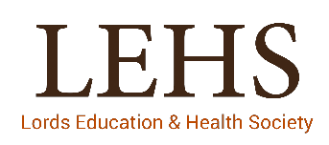
- Work with project staff members to develop a greater understanding of the functioning of the clinics, emerging issues and proactively getting them addressed.

Community Systems Strengthening
- Under the guidance and with Consensus of the BMC officials work for strengthening the community processes in the urban context.
- Support the BMC in developing guidelines and streamlining activities.

- Draft meeting summaries and other reports materials as may be required, in a timely manner;
- Provide administrative support synthesis of lessons learnt and best practices related to program management
- Respond to program related queries from internal and external stakeholders;
- Submission of regular reports to LEHS|WISH;
Any other work that may be assigned as per the need and requirement of the organisation.

Personal Attributes:
- Demonstrates integrity, ethics, compassion and respect;
- Passion for results- Highly motivated and resourceful; demonstrates high accountability, ownership and a go getter attitude; takes initiative and drives results;
- Demonstrates speed, agility and innovation in thought and in action;
- Decision-Making: S/he has the ability to evaluate risks and opportunities; uses analytical and problem-solving skills to arrive at sound business decisions;
- Result Focused: S/he effectively manages time and deliverables for self and team; has a strong sense of ownership; is able to multi-task and work under pressure; demonstrates attention to detail and sets high benchmarks;
- Brand Ambassador: Has a strong professional presence and can be seen as a credible and key representative of WISH to forge strong strategic partnerships;
- People Management: Demonstrated leadership capacity to build and lead technology teams; possesses strong interpersonal abilities and provides necessary direction to team with focus on skill building, overall staff development, enhanced performance and engagement levels; Emotionally intelligent, perceptive and demonstrates inclusiveness and diversity;
- Willingness and ability to travel extensively

About us:
Lords Education and Health Society (LEHS) is a not-for-profit entity that was established in 2003. In 2014, the Wadhwani Initiative for Sustainable Healthcare (WISH), the flagship program of LEHS, was established. LEHS|WISH works towards improving the quality of and access to primary healthcare services for the under-served communities in India. WISH is implementing healthcare models through partnership with state governments, international agencies and the private sector by appropriately introducing promising healthcare innovations in the public health system in order to build an equitable, innovation-led and evidence-based quality healthcare system within easy reach of the underserved populations. LEHS|WISH is committed to building an equitable, quality-assured, innovation-led ecosystem that makes healthcare accessible to the most underserved.

Our Values  At LEHS|WISH we strive to live our values | Our Purpose- Vision, Mission and Goal At LEHS|WISH our purpose governs all our action
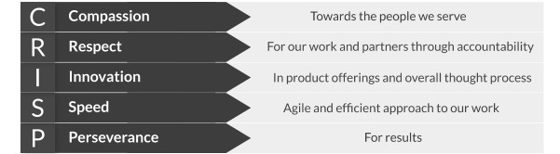 | 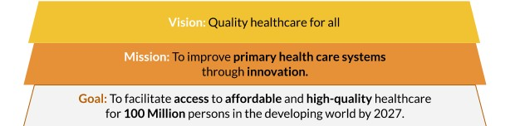

Our Approach
Our work is positioned at the intersection of primary health care and innovations.

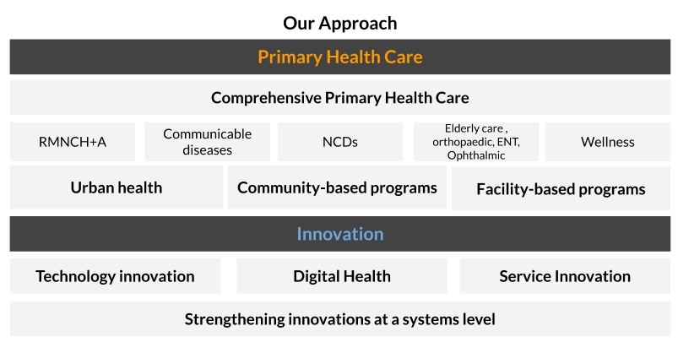

LEHS|WISH is an equal opportunity employer. All candidates applying for the position should submit their resume and cover letter specifying the position name in the subject line along with notice period and current/ expected compensation details to career@wishfoundationindia.org

