JOB DESCRIPTION

Position Title: Digital Health Manager- Project Management Unit (PMU) for Brihanmumbai Municipal Corporation (BMC)
Number of Position(s): 1

Reporting: To the Team Lead
Location: Mumbai

Education: B.Tech/M.Tech/MCA/CSIT

Span of Control: Within PMU

Internal Stakeholders: CEO, Program Director, Functional Heads and entire WISH program and dissemination team.

External Stakeholders: BMC official and other development partners.

Essential Skills:

The incumbent should have -
- The total experience of 5 years is mandatory and the experience related to digital Health strengthening (Primary / Secondary / Tertiary levels) is preferable. Minimum 1 years’ experience with the government/supporting government programs.
- Expertise in health data systems, (HMIS, NFHS, etc.)
- Innovative technology frameworks within Public Health - oversee development and implementation of innovative practices, across systems, process, products and technology within the health care ecosystem.
- The candidate should have practical experience and technical expertise and know-how of the universe focusing on one or more areas of digital health.
- Excellent interpersonal skills with the ability to interact culturally, linguistically, and diplomatically with diverse internal and external individuals.
- Comfortable managing in a flexible, changing and virtual environment, with the ability to be ready to adjust plans and direction in response to local feedback and the iterative nature of digital health projects.
- Strong communicator with a proven ability to explain digital health technical concepts to a non-technical audience in a way that they can understand and appreciate.

Language Proficiency: English and Marathi

Primary Health Care is the interface between the secondary and tertiary health care system and the urban poor and has a pivotal role in delivering necessary primary healthcare services to the urban population particularly the slum and vulnerable sections. In order to address the health concerns of the urban population more effectively and to provide basic essential primary care in close proximity for urban slums, Brihanmumbai Municipal Corporation has introduced the concept of “HBT Clinic” - Essential health care services at time and place convenient and feasible to the citizens. Additionally, HBT Polyclinic and Diagnostic Centers are being set up to upgrade the existing dispensaries where specialist consultation services along with certain diagnostic services (Blood Investigations, X- Ray, USG, ECG etc) will be available.
The overall objective of the initiative is to incorporate specialized set of interventions at primary health care by roping in basic healthcare and access to specialized diagnostic services to improve promotive, preventive, curative health care and to reduce the burden on secondary and tertiary health care system. Specific objectives include
- To strengthen the primary healthcare delivery system for making quality & essential healthcare services accessible, available and affordable to maximum citizens, especially urban slum and vulnerable populations.
- To reduce out of pocket expenditure for accessing basic healthcare services and reduce the load on secondary and tertiary healthcare system.
- To demonstrate technology and innovation led primary healthcare model to improve the access to comprehensive primary healthcare services with focus on general ailments, NCDs, and infectious diseases.
- To improve primary healthcare system, planning, and policy-making through on-field monitoring, data management and evidence-based solutions.
The BMC has invited partners to establish a Program Management Unit (PMU) to provide “technical assistance and knowledge management support” in achieving the above objectives. LEHS/WISH has applied for the same, and in anticipation is seeking application from qualified and experienced candidates for the position of Manager Digital Health, PMU.
The incumbent will work under the Team Lead towards amplifying the organizational impact by providing technical, advisory and programmatic oversight and strategic direction to the proposed PMU of the BMC. The Manager of Digital Health will lead the development and implementation of WISH’s digital health solutions, creating pathways to accelerate the application of digital health solutions in the HBT clinics.
The position will contribute towards establishing a culture of respect, trust, collaboration, learning, innovation, urgency and passion for quality results within the team members and their workings. The individual will exemplify the mission, vision and cultural values of LEHS|WISH through his or her actions.

Job Role:

Digital Health manager would support a team of developers and data engineers in ensuring best practices in digital health product development including front-end, back-end and system architecture. The manager will closely work with project implementation team to understand the requirement and process flow of digital health management at the implementation and execution level, and replicate the need in form of robust applications compatible with mobiles and web-based platforms

The key deliverables will include (but not limited to) the following:
- Provide advice, consultations and training to internal and external experts on current state of digital health technologies, policies, and functionalities.
- Up-to-date knowledge of technologies, methodologies and technology standards and an understanding of the constraints and benefits of different technologies. Proven ability to evaluate effectiveness of and work with various data use and operational solutions and assist with identifying and evaluating technology solutions related to primary health.
- Oversee the strategy, in coordination with program team for employing digital health solutions. Ensure DHT strategies and programming are integrated across multiple technical areas to maximize public health impact.
- Sets the direction in determining appropriate technical assistance required and interventions to develop deploy and maintain digital health solutions.
- Evaluates information systems, tools, strategies and best practices (e.g., Principles for Digital Development) in support of determining WISH Foundation programmatic use of digital health tools.
- Any other work that may be assigned as per the need and requirement of the organisation.

Any other reasonable duty as may be assigned, that is consistent with the nature of the job and the level of responsibility
Necessary Skills:
- Design & development of client-side and server-side application architectures
- Good understanding of OO principles, Algorithms, and Data Structures.
- Excellent problem-solving, debugging, and troubleshooting skills [Client side, Server side, Database.
- Expert-level skills in one or more of core JavaScript
- Data fluency: understands the basics of manipulating data and building analytical models, data management (Azure cloud, SQL, S3, Hadoop, R, Python) technologies and technology choice
- Experience working using CLI in Unix/Linux server environments.
- Experience managing and/or developing data science-based products
- Knowledge (2+ years) of Python language and JavaScript framework React and backend framework (Django with libraries like django-rest-framework)

Desirable skills
- Experience leading a multi-disciplinary, lean team of developers, data engineers and data analysts
- Interest or background in public health & govt. data systems
- Provide necessary Digital support to all the internal teams, programs and stakeholders
- Designing and developing APIs and REST endpoint.

Personal Attributes:
- Demonstrates integrity, ethics, compassion and respect;
- Passion for results- Highly motivated and resourceful; demonstrates high accountability, ownership and a go getter attitude; takes initiative and drives results;
- Demonstrates speed, agility and innovation in thought and in action;
- Decision-Making: S/he has the ability to evaluate risks and opportunities; uses analytical and problem-solving skills to arrive at sound business decisions;
- Result Focused: S/he effectively manages time and deliverables for self and team; has a strong sense of ownership; is able to multi-task and work under pressure; demonstrates attention to detail and sets high benchmarks

About us:
Lords Education and Health Society (LEHS) is a not-for-profit entity that was established in 2003. In 2014, the Wadhwani Initiative for Sustainable Healthcare (WISH), the flagship program of LEHS, was established. LEHS|WISH works towards improving the quality of and access to primary healthcare services for the under-served communities in India. WISH is implementing healthcare models through partnership with state governments, international agencies and the private sector by appropriately introducing promising healthcare innovations in the public health system in order to build an equitable, innovation-led and evidence-based quality healthcare system within easy reach of the underserved populations. LEHS|WISH is committed to building an equitable, quality-assured, innovation-led ecosystem that makes healthcare accessible to the most underserved.
Our Values  At LEHS|WISH we strive to live our values | Our Purpose- Vision, Mission and Goal  At LEHS|WISH our purpose governs all our action

Our Approach
Our work is positioned at the intersection of primary health care and innovations.
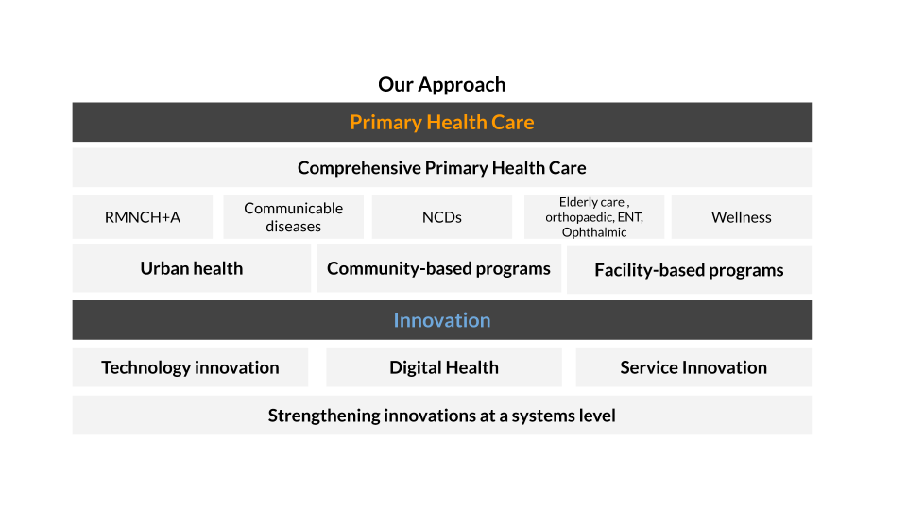
LEHS|WISH is an equal opportunity employer. All candidates applying for the position should submit their resume and cover letter specifying the position name in the subject line along with notice period and current/ expected compensation details to career@wishfoundationindia.org

Date of job posting: October 20, 2022
Please apply by November 3, 2022 for best consideration

